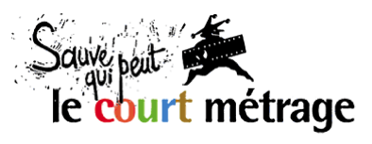 | presents | EURO CONNECTION  04-05 Feb. 2014

Euro Connection is the European Short Film Co-production Forum taking place each year at the Clermont-Ferrand Short Film Market. This business platform aims at fostering partnerships between European production companies, funders and broadcasters for short film projects. Its 6th edition is organised by Sauve Qui Peut le Court Métrage (Clermont-Ferrand) in association with the MEDIA Desk France and the Centre National du Cinéma et de l’Image Animée, with the support of the MEDIA programme and the PROCIREP.

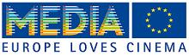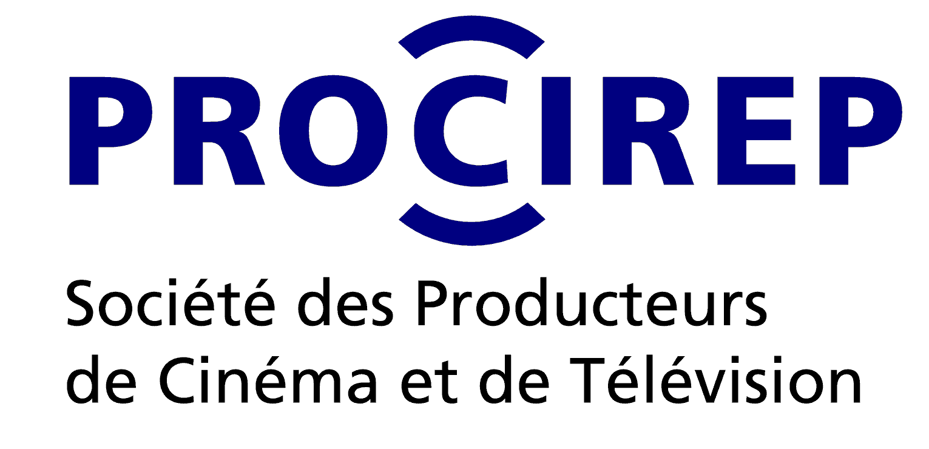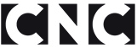

CALL FOR PROJECTS 2014

When is Euro Connection taking place, and when is the deadline?
Euro Connection will take place on Tuesday 4th February 2014 (pitching sessions) and Wednesday 5th February 2014 (one-on-one business meetings) during the Clermont-Ferrand Short Film Market. Deadline for applying with a project is October 31st, 2013.

What kind of projects are accepted and who can apply?
Short film projects with partial funding secured, searching for a co-production partner in Europe.

Requirements
The project is a short film (animation, fiction, documentary).
The project must have partial funding secured in its country of origin.
The project is being developed with a serious approach to European co-production.
Project’s total duration does not exceed 40 minutes.
Shooting shall start no earlier than May 2014.

Eligibility
May apply production companies officially located in one of the 15 countries associated to the 2014 edition: Belgium, Bulgaria, Croatia, Denmark, Finland, France, Germany, Greece, Ireland, Italy, Poland, Portugal, Romania, Sweden, United Kingdom.
Any producer applying with a projects commits to attend personally and pitch the project in case of selection.

Application procedure
Each application must include the following entry form accurately filled out and accompanied by the additional documents that are requested.
Producers must send their application to the national correspondent in their respective country (see table below for contact details). 3 copies in print and 1 electronic copy (a unique pdf file with all documents required) must have reached the national correspondent no later than October 31st, 2013.

Selection of projects
Applications are open starting September 9, 2013.
In each country the national correspondent will collect applications and set up an expert committee to review the applications and select 1 project. The expert committees will especially pay attention to the artistic value of the projects and the quality of the scripts. Each national correspondent will inform the applicants of the results of the selection. The Euro Connection team will then contact the producers of the selected projects to organize their stay and request any material needed. Each producer will need to send an English version of the script prior to attending the event.

Terms of attendance to Euro Connection for selected producers
The producer of each selected project will be invited to Euro Connection (limited to one person per production company). Invitation covers hotel and meals for the duration of their stay (4 hotel nights and meals) and includes full Market accreditation. The producer may be accompanied by the author/director of the project (shared hotel room).
Travel costs are not covered by the invitation and are the responsibility of the producers.

Organization of Euro Connection
The official Book of Projects & Producers 2014 will include descriptions and profiles of the selected projects and the invited producers. It will be made available online at www.clermont-filmfest.com on January 13, 2014. Its publication will then also be publicized to producers, broadcasters, distributors, fund representatives, and financial backers who will be invited to register to attend the pitching sessions during Euro Connection.

Euro Connection will take place on Tuesday 4th February 2014 (pitching sessions) and Wednesday 5th February 2014 (one-on-one business meetings). Each producer will have 10 minutes to pitch his/her project on Tuesday 04th February (in French or in English). A simultaneous translation by headsets will be provided for the audience. Equipment will be installed to show audio-visual presentation material during the pitching sessions.

After the pitching sessions, the French CNC will invite all participants to relax and network informally around a drink.

At the end of the day, each producer will be informed of the one-on-one meetings requests received for their project and taking place the next day. The one-on-one business meetings will take place at the MEDIA Rendez-Vous area, inside the Short Film Market, on Wednesday 5th February (from 10:00 to 16:00). Each meeting is booked for 30 minutes. The Euro Connection team will be there for guidance and assistance.

Producers invited in partnership with other film & media organisation
In partnership with the European correspondents or with other film & media organisations, Euro connection will also invite several additional producers to attend Euro Connection and access the facilities offered on location. Each invited producer will be personally informed of their invitation by the correspondent or partner organisation in their country. The winner of the Baltic Pitching Forum will be invited to attend Euro Connection.

Sending your application
Producers must sent a complete application (project description form + additional material required) to the correspondent organization in their country of location (see table below for contact details). Incomplete applications will not be accepted. The documents that are part of the application shall be reserved for the sole use of the expert committees. However, in case of selection, please note that the information contained in the application will be published and made available online to facilitate networking between production companies. Material received, especially text, may be edited prior to publication to adapt to the Book of Projects’ nomenclature and editorial line.

National correspondent organisations and contact details:

BELGIUM |  | IRELAND
Wallonie Bruxelles Images  18 Place Eugène Flagey  1050 Bruxelles | Geneviève Kinet  32.2 223 23 04  genevieve.kinet@cfwb.be | IndieCork Film Festival  Paradise Place  8 South Main Street  Cork | Una Feely  353.868096305  una@indiecork.com
BULGARIA |  | ITALIE
MEDIA Desk Bulgaria  2A Kniaz Dondukov Blvd.  1000 SOFIA | Kamen Balkanski  Tel. +359.2 988 32 24  info@mediadesk.bg | AIACE - CNC  Via Maria Vittoria 10  10123 Torino | Lia Furxhi  39.011 5361468  info@cnc-italia.it
CROATIA |  | POLAND
MEDIA desk Croatia  Kralja Zvonimira 20  HR - 10 000 Zagreb | Martina Petrovic  385.1 46 55 434  martina.petrovic@mediadesk.hr | Krakow Film Foundation  ul. Basztowa 15/8a  31-143 Kraków | Barbara Orlicz  48.12 294 69 45  barbara.orlicz@kff.com.pl
DENMARK |  | PORTUGAL
MEDIA desk Denmark  Vognmagergade 10  DK-1120 Copenhagen K | Ene Katrine Rasmussen  45.3374 3442  ener@dfi.dk | Festival Curtas Vila do Conde  Auditorio Municipal  Praça da Républica  4480-715 Vila do Conde  Festival IndieLisboa  Av. Guerra Junqueiro, 13, 3ºEsq.  1000-166 Lisboa | Miguel Dias (Vila do Conde)  351. 252 643 386 mdias@curtas.pt  Miguel Valverde (IndieLisboa)  351.213 158 399  miguel.valverde@indielisboa.com
FINLAND |  | ROMANIA
Tampere Short Film Festival  BOX 305  FIN-33101 Tampere | Juhani Alanen  358.3 223 5681  juhani.alanen@tff.fi | Romanian Film Promotion  str. Popa Soare, nr.52, et.1, ap.4, sector 2,  023984 Bucuresti | Ramona Sarbu  Tel/Fax:+40 21 32 66480  ramona@tiff.ro
FRANCE |  | SWEDEN
Sauve Qui Peut le Court Métrage  « La Jetée »  6 place Michel-de-L’Hospital  63058 Clermont-Ferrand cedex 1 | Laurent Crouzeix  33.473 14 73 12  l.crouzeix@clermont-filmfest.com | Swedish Film Institute  P.O. Box 27126  SE-102 52 Stockholm | Andreas Fock  46 8 665 12 15  andreas.fock@sfi.se
GERMANY |  | UNITED KINGDOM
AG Kurzfilm e.V.  German Short Film Association  Förstereistr. 36  01099 Dresden | Franziska Richter  49.351 4045575  richter@ag-kurzfilm.de | British Council  10 Springs Gardens  London SW1A 2BN | Will Massa  44.20 7389 4884  will.massa@britishcouncil.org
GREECE
Greek Film Centre  Dionyssiou Areopagitou, 7  11742 Athens | Stavroula Geronimaki  30.2103678530 stavroula.geronimaki@gfc.gr

Contacts and useful links
For any further query you may contact:

Nathalie Chesnel, Lilyane Crosnier (01 47 27 77 67): info@mediafrance.eu
MEDIA Desk France – The MEDIA Desk France helps to promote and administer the MEDIA programme in France. Information, services, calls for proposals for funding schemes.
www.mediafrance.eu

Laurent Crouzeix: l.crouzeix@clermont-filmfest.com / +33.(0)4 73 14 73 12
Short Film Market Clermont-Ferrand – organised by Sauve Qui Peut le Court Métrage.
www.clermont-filmfest.com

Morad Kertobi: morad.kertobi@cnc.fr
C.N.C - missions, film heritage, news, events, publications, key figures, useful info.
www.cnc.fr
Project description form – Euro Connection 2014

Short film project
Original title: ……………………………………………………………………………………...……
English (or international) title: ………………………………………………………………………
Directed by: …………………………………………………………………………………………...
Script by: …………………………………………………………………………………………….....
Production company: ………………………………………… Country:…………………........
Producer’s name: …………………………………………………………………………………….

Key contact details
Producer’s e-mail:………………………………... Mobile phone: …………………………………..
Director’s e-mail:………………………………….. Mobile phone: ……………………………………
Production company’s address:........................................................................................................
Postcode: ………………… City: …………………………………………………………
Phone: ………………………………….. Website:……………………………………….......

Tech specs
Genre:  fiction  animation  creative documentary
Planned shooting format: ……………………………………………
Estimated running time: ………………….. minutes
Planned dates of shooting: ........................................................................

Short synopsis / description (500 signs max.):

Director’s short bio (750 signs max.)

Production company profile (500 signs max.)

Producer’s short bio (750 signs max.)

Budget and financing
Total estimated budget (in euros): ……………………………………… €
Secured funding (at time of application): ……..…..………............... € ( … % of budget)
Nature of secured financing:
❒ script development grant  broadcaster
❒ state production fund  prize/award/foundation money
❒ local/regional/city production fund  other (specify:…………………...................)
Funding granted by (name of organization):...............................
Funding confirmed on (date): ..................................

Other confirmed production, distribution or broadcasting partners (company + country + name of contact person): …………………………………………………………………………..............

Additional following documents are requested

- This project description form duly filled out;
- Complete script
- Production company's background and filmography;
- CV of producer;
- CV of director;
- The producer's letter of motivation and strategy for producing this film;
- The director's letter of intent;
- Proof of secured funding (confirmation notice, letter, etc.);
- Available visuals (storyboard, locations, moodboard, animatic…)
- Whenever possible, a DVD or links of a previous film (or clips) by same director or producer;
- A paginated table of content for entire application.

No minimum amount is required, yet the partial funding secured must come from a third party organisation (i.e script development grant, production fund, state or local government support, investment from a broadcaster, prize money from a foundation or contest, etc.) In-kind contributions or investment share from the original production company are not considered valid as acquired partial funding in the respect of this selection procedure.

